Contents

Data Set Up 2

Styling 3

Starter Code 3

Exercise 1 4

Exercise 2 5

Exercise 3 6

Exercise 4 7

Exercise 5 8

Exercise 6 9

Answer Key 10

Proc Report Step by Step

In this hands-on training session, you will learn to create PROC REPORT code for multiple report types. Each concept and report type will be explained, then you will spend time writing code to create your own report. WUSS will not be providing laptops. Please bring your own device so you can get the most out of this training opportunity.

# Data Set Up

The Ames Housing data will be used for all exercises during the workshop. Follow these instructions for creating the data and corresponding formats.

1. Locate the createdata.sas program at XXXX.
2. Download the file and open it in your preferred SAS environment.
3. Run the program. The data and formats are stored in the Work directory.
4. Submit the following OPTIONS and TITLE statements.

options missing=**0**;

title1 'Ames Housing';

These are the variables that will be utilized frequently during the workshop.

|  |  |
| --- | --- |
| Key Variables | Formats |
| Bldg_type | $bldg_type |
| Electrical | $electrical |
| Sale_type | $sale_type |
| Yr_sold |  |
| Saleprace | Dollar15.2 |
| Gr_liv_are | 8. |

# Styling

[Style Attributes documentation](https://go.documentation.sas.com/doc/en/pgmsascdc/v_028/odsproc/n1b4339kviqrrcn1lt1lbm68e8xx.htm)

STYLE(<location>)= in PROC REPORT and/or DEFINE statements

[Location documentation](https://go.documentation.sas.com/doc/en/pgmsascdc/v_028/proc/p14xegao6xt0xnn1865r422tpytw.htm)

* CALLDEF
* COLUMN
* HEADER
* LINES
* SUMMARY

Example:

define city / style(header)={font_weight=bold};

CALL DEFINE

Sets the value of an attribute for a particular column or row. A CALL DEFINE statement is only valid within a compute block. [Documentation](https://go.documentation.sas.com/doc/en/pgmsascdc/v_028/proc/n1b1be5822k8nnn1s1ucv8fvpg3d.htm)

CALL DEFINE (column-id | _ROW_, 'attribute-name', value);

Column-id: character literal, character expression, numeric literal, numeric expression, _cn_, _col_

Attribute-name: format, url, style, style/merge

Example:

call define(_col_,'style','style={foreground=red}');

call define('price.sum','style','style={background=blue}');

## Starter Code

**proc** **report** data=ameshousing;

where yr_sold=**2010**;

format bldg_type $bldg_type. sale_type $sale_type.;

column bldg_type sale_type saleprice gr_liv_area;

define bldg_type / group;

define sale_type / group;

define saleprice / mean format=dollar15.2;

define gr_liv_area / mean format=**8.**;

break after bldg_type / summarize;

rbreak after / summarize;

## Exercise 1

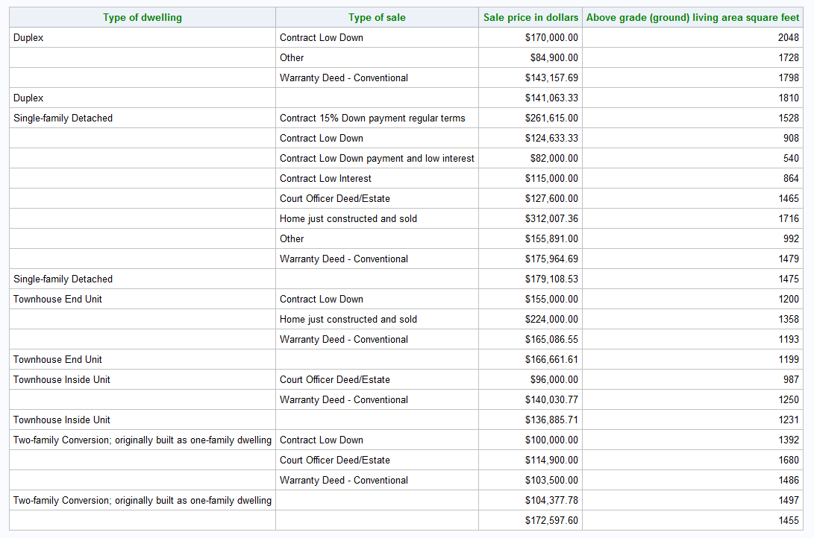

## Exercise 2

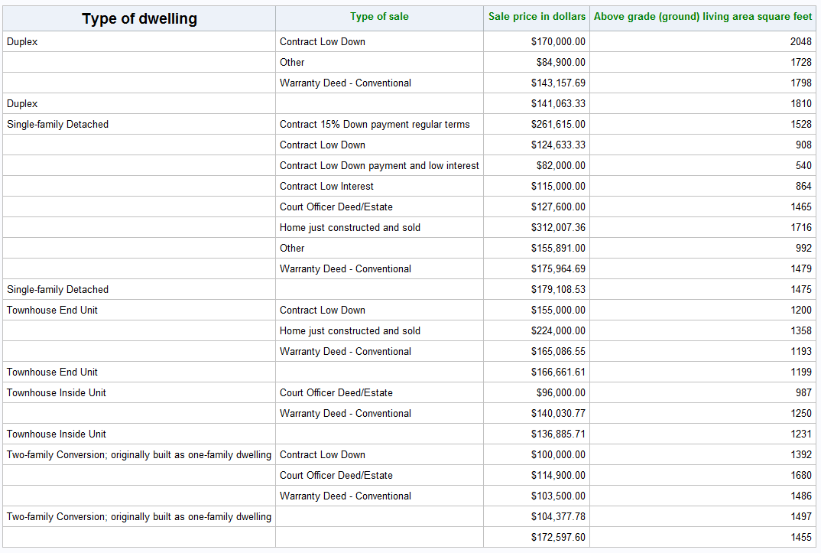

## Exercise 3

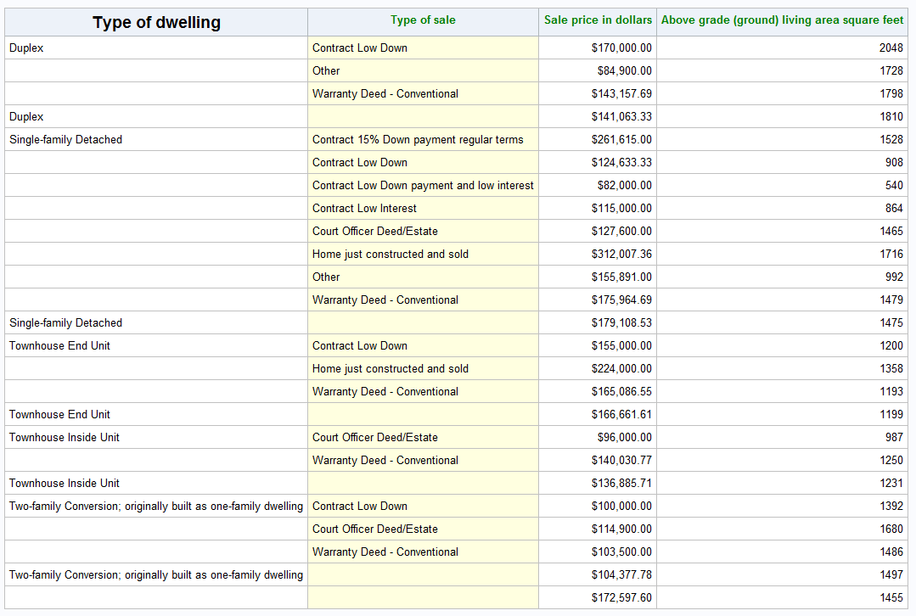

## Exercise 4

title3 'Use STYLE= and a format';

**proc** **format**;

value size

low-**500** = 'red'

**500**-**700** = 'orange'

**700**-**1000** = 'yellow'

**1000**-**1500** = 'lightgreen'

**1500**-high = 'green';

**run**;

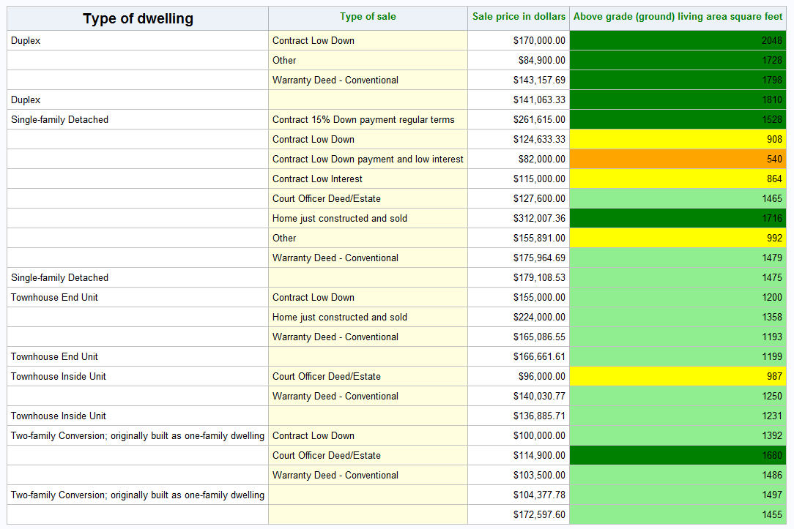

## Exercise 5

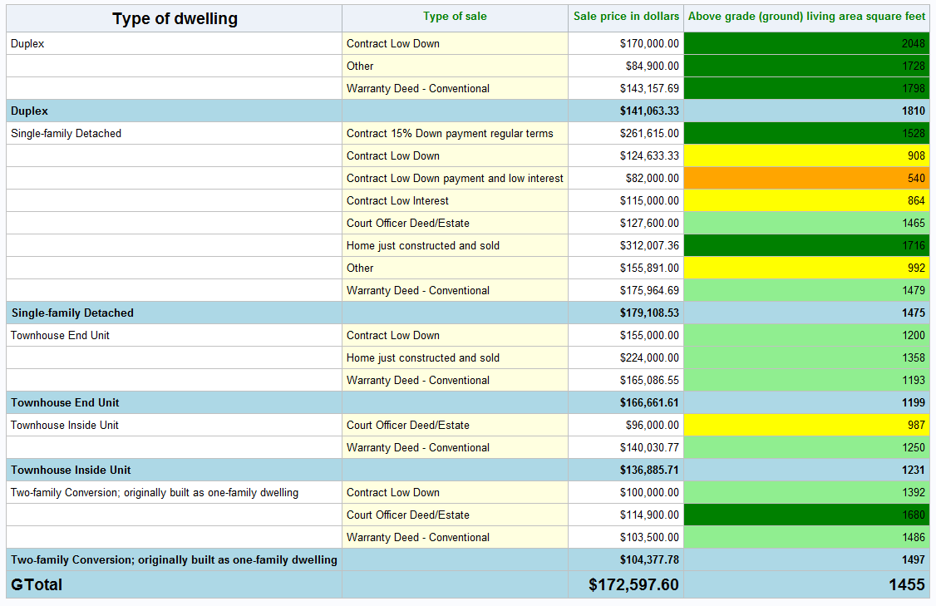

## Exercise 6

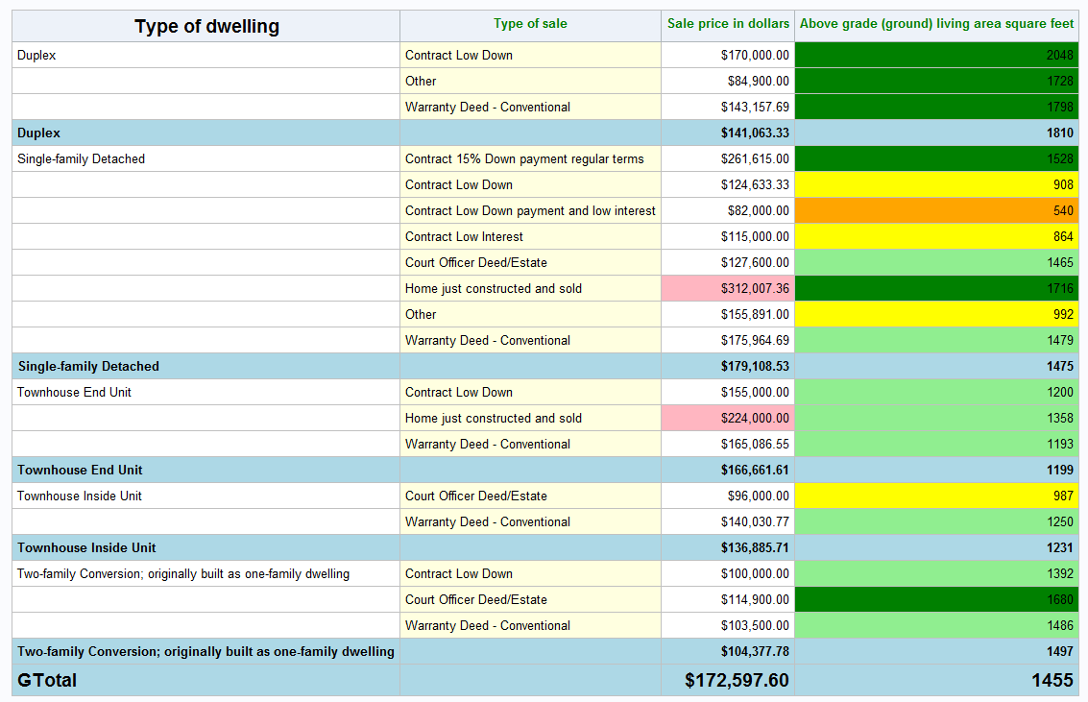

# Answer Key

options missing=**0**;

title1 'Ames Housing';

*****************

STYLING

*****************;

title2 'Styling';

*STYLE= option in PROC REPORT statement - Exercise 1;

title3 'STYLE= for header in PROC REPORT statement';

**proc** **report** data=ameshousing style(header)=[foreground=green];

where yr_sold=**2010**;

format bldg_type $bldg_type. sale_type $sale_type.;

column bldg_type sale_type saleprice gr_liv_area;

define bldg_type / group;

define sale_type / group;

define saleprice / mean format=dollar15.2;

define gr_liv_area / mean format=**8.**;

break after bldg_type / summarize;

rbreak after / summarize;

**run**;

*STYLE= option in DEFINE statement for header - Exercise 2;

title3 'STYLE= for header in DEFINE statement';

**proc** **report** data=ameshousing style(header)=[foreground=green];

where yr_sold=**2010**;

format bldg_type $bldg_type. sale_type $sale_type.;

column bldg_type sale_type saleprice gr_liv_area;

define bldg_type / group style(header)=[foreground=black font_size=**14**pt];

define sale_type / group;

define saleprice / mean format=dollar15.2;

define gr_liv_area / mean format=**8.**;

break after bldg_type / summarize;

rbreak after / summarize;

**run**;

*STYLE= option in DEFINE for column data - Exercise 3;

title3 'STYLE= for column in DEFINE statement';

**proc** **report** data=ameshousing style(header)=[foreground=green];

where yr_sold=**2010**;

format bldg_type $bldg_type. sale_type $sale_type.;

column bldg_type sale_type saleprice gr_liv_area;

define bldg_type / group style(header)=[foreground=black font_size=**14**pt];

define sale_type / group style(column)=[background=lightyellow];

define saleprice / mean format=dollar15.2;

define gr_liv_area / mean format=**8.**;

break after bldg_type / summarize;

rbreak after / summarize;

**run**;

*STYLE= option in DEFINE statement using a format - Exercise 4;

title3 'Use STYLE= and a format';

**proc** **format**;

value size

low-**500** = 'red'

**500**-**700** = 'orange'

**700**-**1000** = 'yellow'

**1000**-**1500** = 'lightgreen'

**1500**-high = 'green';

**run**;

**proc** **report** data=ameshousing style(header)=[foreground=green];

where yr_sold=**2010**;

format bldg_type $bldg_type. sale_type $sale_type.;

column bldg_type sale_type saleprice gr_liv_area;

define bldg_type / group style(header)=[foreground=black font_size=**14**pt];

define sale_type / group style(column)=[background=lightyellow];

define saleprice / mean format=dollar15.2;

define gr_liv_area / mean format=**8.** style(column)=[background=size.];

break after bldg_type / summarize;

rbreak after / summarize;

**run**;

*add style formatting to summary rows - Exercise 5;

*notice how this overwrites some of the other formatting;

title3 'Summary rows style formatting';

**proc** **report** data=ameshousing style(header)=[foreground=green] style(summary)=[font_weight=bold background=lightblue];

where yr_sold=**2010**;

format bldg_type $bldg_type. sale_type $sale_type.;

column bldg_type sale_type saleprice gr_liv_area;

define bldg_type / group style(header)=[foreground=black font_size=**14**pt];

define sale_type / group style(column)=[background=lightyellow];

define saleprice / mean format=dollar15.2;

define gr_liv_area / mean format=**8.** style(column)=[background=size.];

break after bldg_type / summarize;

rbreak after / summarize;

compute after;

bldg_type = 'GTotal';

call define(_row_,'style','style={font_size=14pt}');

endcomp;

**run**;

*add style based on another column - Exercise 6;

title3 'Style based on another row';

**proc** **report** data=ameshousing style(header)=[foreground=green] style(summary)=[font_weight=bold background=lightblue];

where yr_sold=**2010**;

format bldg_type $bldg_type. sale_type $sale_type.;

column bldg_type sale_type saleprice gr_liv_area;

define bldg_type / group style(header)=[foreground=black font_size=**14**pt];

define sale_type / group style(column)=[background=lightyellow];

define saleprice / mean format=dollar15.2;

define gr_liv_area / mean format=**8.** style(column)=[background=size.];

break after bldg_type / summarize;

rbreak after / summarize;

compute after;

bldg_type = 'GTotal';

call define(_row_,'style','style={font_size=14pt}');

endcomp;

compute saleprice;

if sale_type = 'New' then call define(_col_,'style','style={background=lightpink}');

*if sale_type = 'New' then call define('saleprice.mean','style','style={background=lightpink}');

*if put(sale_type,$sale_type.) = 'Home just constructed and sold' then call define(_col_,'style','style={background=lightpink}');

endcomp;

**run**;